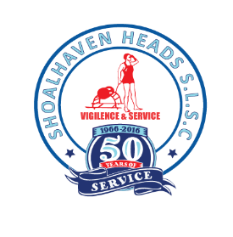
57th Annual General Meeting of Shoalhaven Heads Surf Life Saving Club Incorporated
Sunday 15 September 2024 at 11am
AGENDA
- Meeting open and welcome
- Attendance and apologies
- Confirmation of minutes of the 57th Annual General Meeting season 2023/2024
- Matters arising from those minutes
- Presentation of the Annual Report for season 2023/2024
- Presentation of the Financial Statement season 2023/2024
- Dissolution of existing Board
- Election of Office Bearers for season 2024/2025
Election of up to 9 Directors to form the Club Management Board
The Management Board will include principal positions of
- Director of Administration (Secretary)
- Director of Finance (Treasurer)
- Director Life Saving (Club Captain)
- President (any Director & voted to position from within the elected Director Group)
- Up to 6 additional General Directors
9. Special resolution 1: Declaration of Affiliation with Surf Life Saving South Coast Inc and Surf Lifesaving New South Wales Inc for the 2024/2025 season
10.Special resolution 2: Member Recognition
• 3 members referred to SLSA for recognition of service for National Service Medal, C Poulton, W Davis D Wildi
• Motion 1: change to constitution to allow nomination of members to receive club honour member status
• Motion 2: Club recognises service by Members D Wildi N Pryde in awarding Club Honours Membership
11.Urgent general business
- Motion to support and pay for Surf Ski Training – Phil PB
- Any other urgent matters
Next Meeting – Sunday 22nd Sept 2024 930am
Meeting closed

