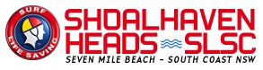
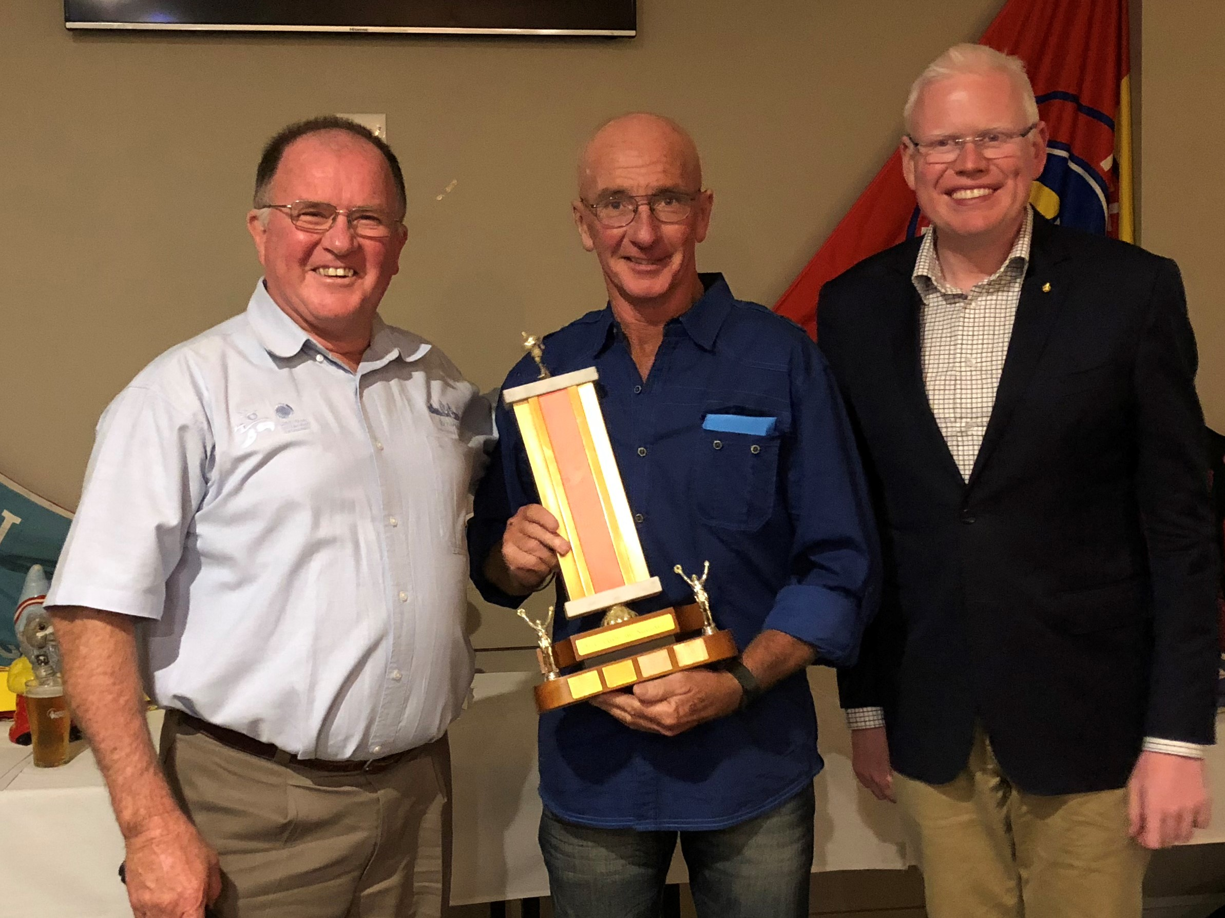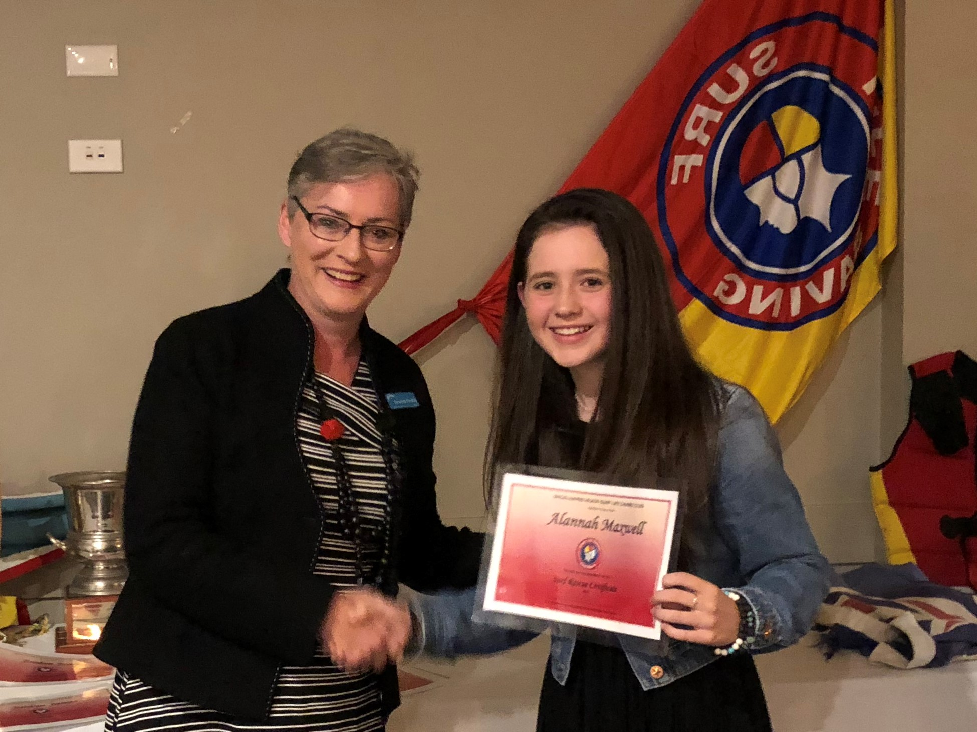

The season end presentation night was held on June 12th at Heads Bowlo which is one of our community sponsors, so thank you to the Directors and Clubs NSW Club for the support through grants and cooperation. Members and families were joined by our life members plus guests Gareth Ward, Member for Kiama, Ann Sudmalis and Amanda Findlay Mayor of Shoalhaven with apologies from councillors John Wells and Patricia White. Karl Poulton, President thanked them and our sponsors for their continuing support particularly through NSW government grants for building enhancements, council work on maintenance and beach repairs and local businesses for donations and equipment . Certificates and medals were presented to members who did Surf Lifesaving Australia Bronze Medallion and Surf Life Saving Certificates for patrolling as well as additional awards for IRB crew and driver, certificates for spinal care, advanced resuscitation, beach management and approved trainer. Their achievements represent a great commitment to community safety and volunteering to our village. Major annual awards, voted on by all members, were achieved by Graham Morrison: Club all-rounder and Patrolman; Mike Janos: Trainer; Jaiden Murphy: Junior Club Person ; Allanah Mannix: Junior Patrol Person; Rod Douglass: Club Man; Patrol 1: Patrol Team of year. Gareth, Ann and Amanda spoke to acknowledge and thank members for their dedication and service through good emergency response management and public safety education.
Important future dates for members and community
29 July : AGM - anyone in the community is welcome
August 19 : Pre Season Gear Inspection August 19th –all patrol to attend
September 16 tbc : Rego Day with Fun Run
: Bronze Medallion and Surf Rescue Certificate courses (14 yrs+) info
September 23: members Summer Equinox BBQ . Training Courses start
October 14: Nippers start 9am
Membership recruitment is always open: registrar@headssurf.com.au or northview5960@gmail.com ph: 0432331915 or post your message via Facebook Shoalhaven Heads Surf Life Saving Club or www.headssurf.com.au
General admin: secretary@headssurf.com.au
Club Hall Hire via Louise at the Heads Kiosk Thurs-Mon 7.15-2ish or 0466049650.
In the event of a public safety incident in the area and patrol is not on duty ring emergency services 000.

